Lab Plan 7: Interactive Flutter UIs (Gestures & Sliders)
Phase 1: GestureDetector

Task 1.1: Create a Container (200x200) with a unique background color.

Task 1.2: Wrap the container in a GestureDetector.

Task 1.3: Logic Implementation:

onTap: Change the container's color to a random Colors value.
onDoubleTap: Toggle the borderRadius between 0 and 100 (Square to Circle).
onLongPress: Show a SnackBar saying "Resetting..." and return the box to its original state.
Code:
import 'package:flutter/material.dart';
import 'dart:math';

void main() {
runApp(const MyApp());
}

class MyApp extends StatelessWidget {
const MyApp({super.key});

@override
Widget build(BuildContext context) {
return MaterialApp(
title: 'Lab 7 - Phase 1: GestureDetector',
theme: ThemeData(colorSchemeSeed: Colors.blue, useMaterial3: true),
home: const GestureScreen(),
);
}
}

class GestureScreen extends StatefulWidget {
const GestureScreen({super.key});

@override
State<GestureScreen> createState() => _GestureScreenState();
}

class _GestureScreenState extends State<GestureScreen> {
// Original / default values
static const Color _originalColor = Colors.teal;
static const double _originalRadius = 0.0;

Color _boxColor = _originalColor;
double _borderRadius = _originalRadius;

final Random _random = Random();

Color _randomColor() {
final colors = [
Colors.red,
Colors.orange,
Colors.yellow,
Colors.green,
Colors.blue,
Colors.indigo,
Colors.purple,
Colors.pink,
Colors.cyan,
Colors.amber,
];
return colors[_random.nextInt(colors.length)];
}

void _onTap() {
setState(() {
_boxColor = _randomColor();
});
}

void _onDoubleTap() {
setState(() {
_borderRadius = _borderRadius == 0.0 ? 100.0 : 0.0;
});
}

void _onLongPress() {
setState(() {
_boxColor = _originalColor;
_borderRadius = _originalRadius;
});
ScaffoldMessenger.of(context).showSnackBar(
const SnackBar(
content: Text('Resetting...'),
duration: Duration(seconds: 2),
),
);
}

@override
Widget build(BuildContext context) {
return Scaffold(
appBar: AppBar(
title: const Text('Phase 1: GestureDetector'),
backgroundColor: Theme.of(context).colorScheme.inversePrimary,
),
body: Center(
child: Column(
mainAxisAlignment: MainAxisAlignment.center,
children: [
const Text(
'Tap → Random Color\nDouble Tap → Toggle Shape\nLong Press → Reset',
textAlign: TextAlign.center,
style: TextStyle(fontSize: 16, color: Colors.black54),
),
const SizedBox(height: 40),
GestureDetector(
onTap: _onTap,
onDoubleTap: _onDoubleTap,
onLongPress: _onLongPress,
child: AnimatedContainer(
duration: const Duration(milliseconds: 300),
width: 200,
height: 200,
decoration: BoxDecoration(
color: _boxColor,
borderRadius: BorderRadius.circular(_borderRadius),
),
),
),
],
),
),
);
}
}

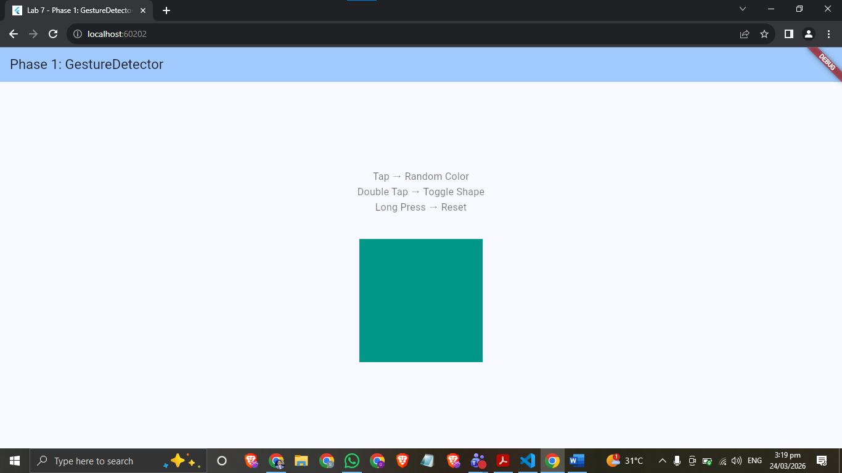
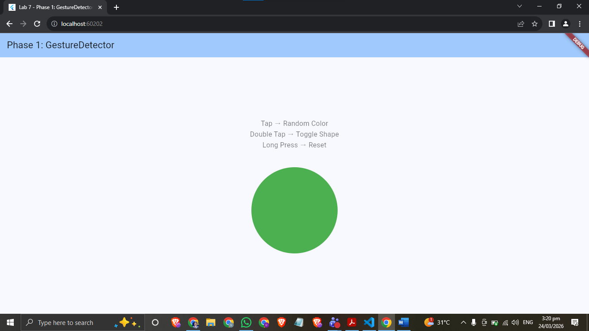

Phase 2: Sliders
Task 2.1: Create a vertical Column containing a Text widget displaying a "Value" variable.
  - Task 2.2: Add a Slider widget: Set min to 0.0 and max to 100.0.
  - Set divisions to 10 to create discrete steps.
  - Update the "Value" text in real-time within onChanged.

  - Task 2.3: Implement a CupertinoSlider below the Material one to observe the difference in native "look and feel."
Code:
import 'package:flutter/cupertino.dart';
import 'package:flutter/material.dart';

void main() {
runApp(const MyApp());
}

class MyApp extends StatelessWidget {
const MyApp({super.key});

@override
Widget build(BuildContext context) {
return MaterialApp(
title: 'Lab 7 - Phase 2: Sliders',
theme: ThemeData(colorSchemeSeed: Colors.deepPurple, useMaterial3: true),
home: const SliderScreen(),
);
}
}

class SliderScreen extends StatefulWidget {
const SliderScreen({super.key});

@override
State<SliderScreen> createState() => _SliderScreenState();
}

class _SliderScreenState extends State<SliderScreen> {
double _materialValue = 0.0;
double _cupertinoValue = 0.0;

@override
Widget build(BuildContext context) {
return Scaffold(
appBar: AppBar(
title: const Text('Phase 2: Sliders'),
backgroundColor: Theme.of(context).colorScheme.inversePrimary,
),
body: Padding(
padding: const EdgeInsets.all(24.0),
child: Column(
mainAxisAlignment: MainAxisAlignment.center,
crossAxisAlignment: CrossAxisAlignment.start,
children: [
// ── Material Slider ──
const Text(
'Material Slider',
style: TextStyle(fontSize: 18, fontWeight: FontWeight.bold),
),
const SizedBox(height: 8),
Center(
child: Text(
'Value: ${_materialValue.toStringAsFixed(1)}',
style: const TextStyle(fontSize: 22),
),
),
Slider(
value: _materialValue,
min: 0.0,
max: 100.0,
divisions: 10,
label: _materialValue.toStringAsFixed(1),
onChanged: (val) {
setState(() {
_materialValue = val;
});
},
),
const Divider(height: 48),

// ── Cupertino Slider ──
const Text(
'Cupertino Slider',
style: TextStyle(fontSize: 18, fontWeight: FontWeight.bold),
),
const SizedBox(height: 8),
Center(
child: Text(
'Value: ${_cupertinoValue.toStringAsFixed(1)}',
style: const TextStyle(fontSize: 22),
),
),
const SizedBox(height: 8),
CupertinoSlider(
value: _cupertinoValue,
min: 0.0,
max: 100.0,
divisions: 10,
onChanged: (val) {
setState(() {
_cupertinoValue = val;
});
},
),
],
),
),
);
}
}

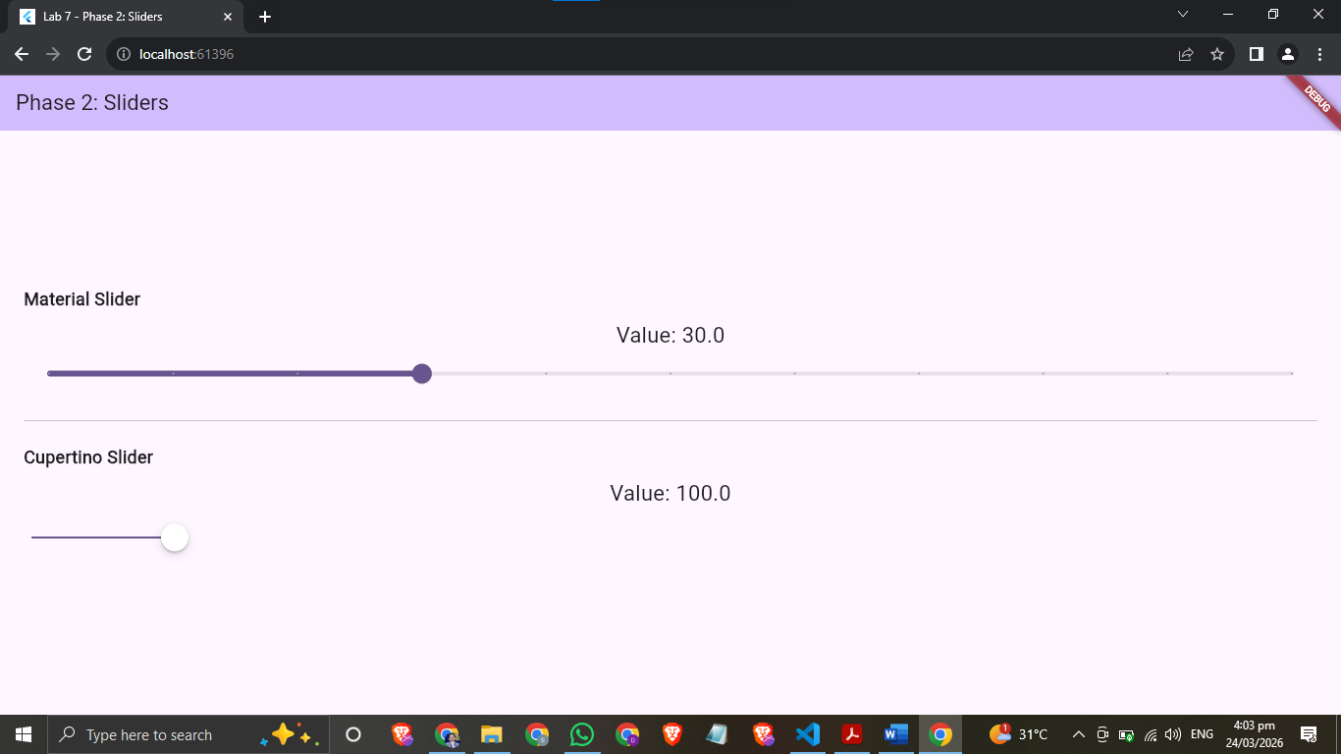

Phase 3: The "Mood & Color" Mixer
The Challenge: Build a mini-app on a single screen where:
- Three Sliders control the Red, Green, and Blue channels of a preview box.
- A GestureDetector on the preview box allows the user to Long Press to "Copy" the Hex code to the console.
- Horizontal Drag (onHorizontalDragUpdate): Should scale the size of the preview box up or down.
Code:
import 'package:flutter/material.dart';

void main() {
runApp(const MyApp());
}

class MyApp extends StatelessWidget {
const MyApp({super.key});

@override
Widget build(BuildContext context) {
return MaterialApp(
title: 'Lab 7 - Phase 3: Mood & Color Mixer',
theme: ThemeData(colorSchemeSeed: Colors.teal, useMaterial3: true),
home: const ColorMixerScreen(),
);
}
}

class ColorMixerScreen extends StatefulWidget {
const ColorMixerScreen({super.key});

@override
State<ColorMixerScreen> createState() => _ColorMixerScreenState();
}

class _ColorMixerScreenState extends State<ColorMixerScreen> {
double _red = 128;
double _green = 128;
double _blue = 128;

// Preview box size (changed by horizontal drag)
double _boxSize = 200.0;
static const double _minSize = 80.0;
static const double _maxSize = 320.0;

Color get _previewColor =>
Color.fromARGB(255, _red.toInt(), _green.toInt(), _blue.toInt());

String get _hexCode =>
'#${_red.toInt().toRadixString(16).padLeft(2, '0').toUpperCase()}'
'${_green.toInt().toRadixString(16).padLeft(2, '0').toUpperCase()}'
'${_blue.toInt().toRadixString(16).padLeft(2, '0').toUpperCase()}';

void _onLongPress() {
// "Copy" hex to console (debugPrint simulates clipboard in lab context)
debugPrint('Hex Code copied: $_hexCode');
ScaffoldMessenger.of(context).showSnackBar(
SnackBar(
content: Text('Hex Code: $_hexCode (printed to console)'),
duration: const Duration(seconds: 2),
),
);
}

void _onHorizontalDragUpdate(DragUpdateDetails details) {
setState(() {
_boxSize = (_boxSize + details.delta.dx).clamp(_minSize, _maxSize);
});
}

Widget _buildSlider({
required String label,
required double value,
required Color activeColor,
required ValueChanged<double> onChanged,
}) {
return Row(
children: [
SizedBox(
width: 24,
child: Text(
label,
style: TextStyle(
fontWeight: FontWeight.bold,
color: activeColor,
fontSize: 16,
),
),
),
Expanded(
child: Slider(
value: value,
min: 0,
max: 255,
divisions: 255,
activeColor: activeColor,
label: value.toInt().toString(),
onChanged: onChanged,
),
),
SizedBox(
width: 36,
child: Text(
value.toInt().toString(),
style: const TextStyle(fontSize: 14),
),
),
],
);
}

@override
Widget build(BuildContext context) {
return Scaffold(
appBar: AppBar(
title: const Text('Phase 3: Mood & Color Mixer'),
backgroundColor: Theme.of(context).colorScheme.inversePrimary,
),
body: Padding(
padding: const EdgeInsets.symmetric(horizontal: 24, vertical: 16),
child: Column(
crossAxisAlignment: CrossAxisAlignment.center,
children: [
// ── RGB Sliders ──
_buildSlider(
label: 'R',
value: _red,
activeColor: Colors.red,
onChanged: (v) => setState(() => _red = v),
),
_buildSlider(
label: 'G',
value: _green,
activeColor: Colors.green,
onChanged: (v) => setState(() => _green = v),
),
_buildSlider(
label: 'B',
value: _blue,
activeColor: Colors.blue,
onChanged: (v) => setState(() => _blue = v),
),

const SizedBox(height: 12),

// ── Hex label ──
Text(
'Hex: $_hexCode',
style: const TextStyle(fontSize: 18, fontWeight: FontWeight.w600),
),

const SizedBox(height: 8),
const Text(
'Long Press → print Hex | Drag ← → to resize',
style: TextStyle(fontSize: 12, color: Colors.black45),
),
const SizedBox(height: 16),

// ── Preview Box ──
Expanded(
child: Center(
child: GestureDetector(
onLongPress: _onLongPress,
onHorizontalDragUpdate: _onHorizontalDragUpdate,
child: AnimatedContainer(
duration: const Duration(milliseconds: 50),
width: _boxSize,
height: _boxSize,
decoration: BoxDecoration(
color: _previewColor,
borderRadius: BorderRadius.circular(16),
boxShadow: [
BoxShadow(
color: _previewColor.withOpacity(0.5),
blurRadius: 20,
spreadRadius: 4,
),
],
),
child: Center(
child: Text(
_hexCode,
style: TextStyle(
fontSize: 18,
fontWeight: FontWeight.bold,
color: ThemeData.estimateBrightnessForColor(
_previewColor) ==
Brightness.dark
? Colors.white
: Colors.black,
),
),
),
),
),
),
),
const SizedBox(height: 16),
],
),
),
);
}
}
